ELEC 5220/6220 Information Networks and Technology

ECOMMERCE PROJECT REPORT

Lingjun Gao

# Abstract

On line shopping becomes an important part of our life at present. Sometimes we prefer to open browser, scan goods and buy it online instead of going to a reality store if we don’t like go out door. The website for online shopping is an interesting project for students. We can not only practice several web script languages we have learnt before in this project, but also learn how to build an integrated website. The website contains several parts. The database is used to store user’s information and items information. We can update database to update the goods for customers. On the other hand, when customer order goods, their personal information and order information will be store in database. Another part in this project is web page design. In order to afford better User Experience, we have to design the page beautiful and let pages attract customers stay on this website. Apart from page typeset, we have to design reasonable hyperlink, which let customers scan website convenience. The last significant part of project is arithmetic design in some pages. For example, we need to add inventory control which check whether the items left is enough. We have to check customer information to make sure their input is availability. With these designs, the web page will reach basic requirement for a commerce shopping website.

# Introduction

In order to improve User Experience, I design perfect extra pages in some steps when customer scans items. What’s more, some detail designs can attract customer’s eyes. When user begins to shop, he is encouraged to login, which will identify who is the user. If the user is the first time to visit the page, he needs to create a new account for shopping. If the user browse the page before and have cookies in present browser, the website will detect user’s cookies and waive the login step. The new feature is designed to make e_commerce more reality. Another use of cookie is display how many times user visits the page. When user login the page, his visit time will add one, and the total visit number will display on the middle of head title. The counter will be stored in database with other user’s information. This design is different from the example in scp page. In order to reach an effect that the counter will add one when user login, but will remain unchanged if he scans and not reopen the browser, I use the session ID to detect whether user reopen the browser, because if browser is reopened the session ID will change. Therefore, if the session ID in browser at present is different from the last session ID when load this page, which is saved in database, the counter will add one and then the counter and present session ID will be saved in database too. On the contrary, if ID is unchanged, counter will remain.

# Design

The project contains two parts, one is website design for computer and another part is design for android client. In this chapter, I will introduce significant steps to complete shopping using both PC and android client. What’s more, the extra new feature will be explained in details.

1. **DATABASE**

In this project, I establish a e_store to display different kind of computer. The database contains four tables, items_laptop, customer_information, customer_login and customer_order. Items_laptop only includes six kinds of computers at present and can be increased easily later. The database stores lots of information about these computers and they can be assorted in several categories.

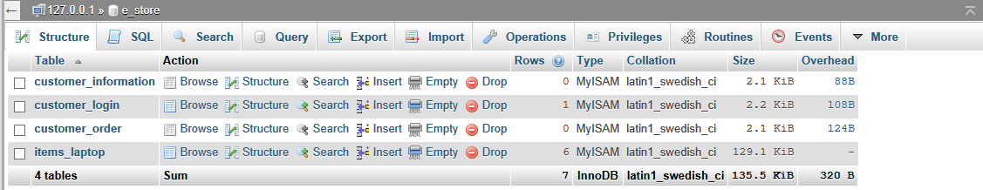

figure databse e_store contains four tables

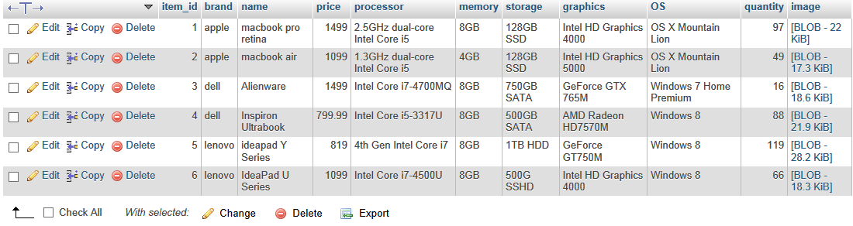

figure items_laptop is used to store computer information

The table customer_information includes customer’s shipping information and credit card.

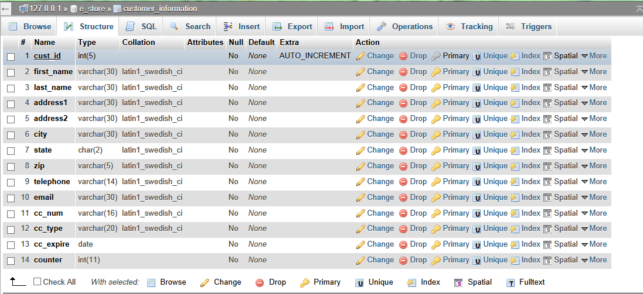

figure structure of customer_information

customer_login contains user’s last name, which is primary key in the table, cust_session_id, which is used to check whether user open a new browser, counter, which is used to store user visit number, password, which used to login.

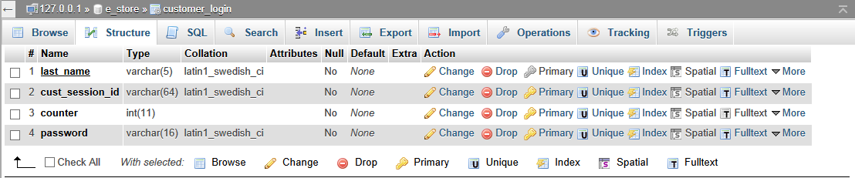

figure structure of customer_login

customer_order contains user’s order information, which is used for delivery and history to review in the future.

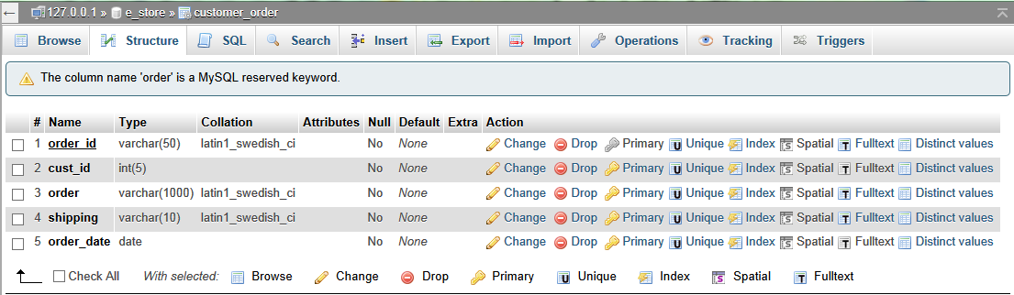

figure structure of customer_order

1. **WEBPAGE**

The first page when browse e_store is index.php. The page contains three basic frames. The header is on the top and footer is on the bottom. The browse and search items afford user several ways to scan prefer items. Some random items and their information will display in a conspicuous place in the page to afford a quick view.

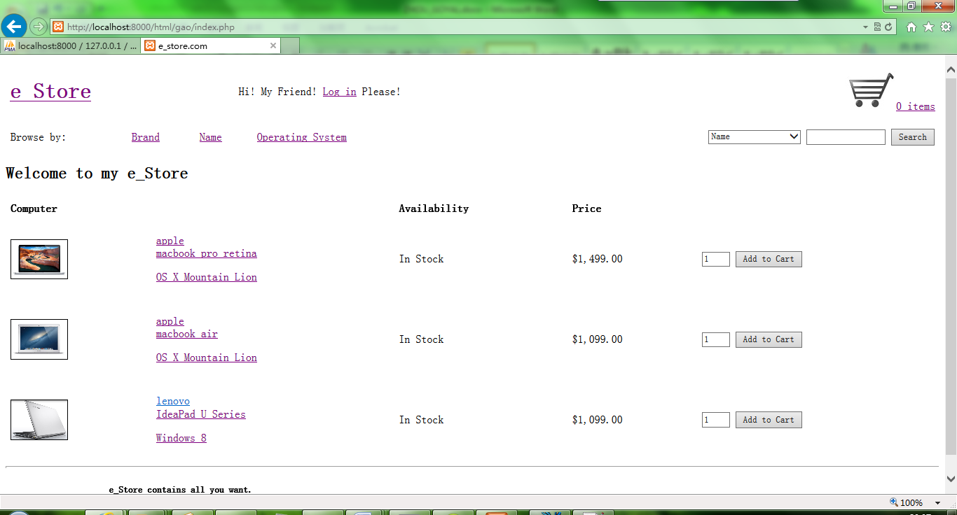

figure index.php is the first visit page

Before select favorite items, customer is encouraged to log in his account. The log in hyperlink is in the middle of header. Click it and turn into log in page.

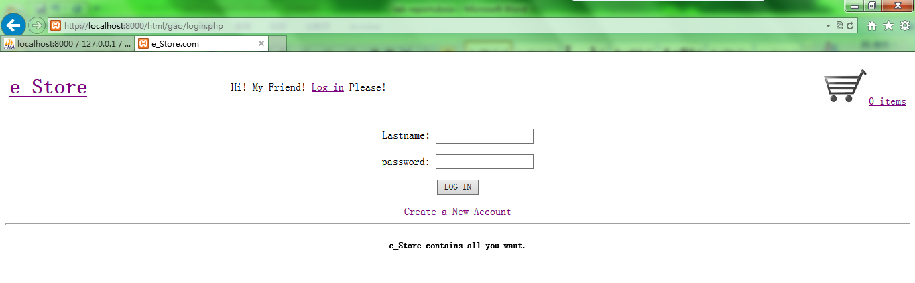

figure log in page

If customer has an account already, he can use his lastname and password to login. While for customer first visit e_store, he can create a new account and the hyperlink is also given in the page.

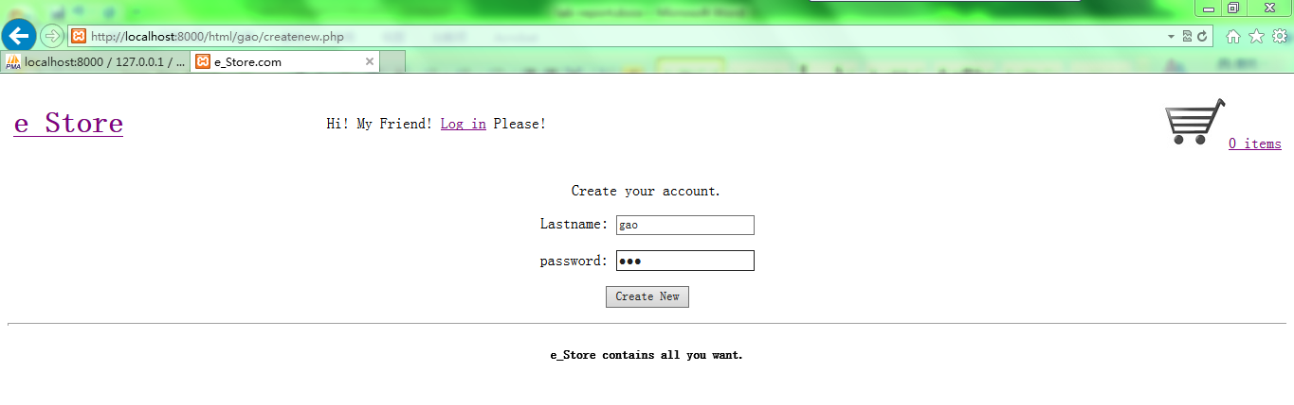

figure page to create new account

If you create successful, customer will lead to a temporary page. At the same time, the website will build customer login information in database. The information includes user’s lastname, current session ID, counter and password.

Aside from update database, two cookies will established no matter user create new account or login with already account. One cookie is user’s lastname, which is used to check who the user is and another cookie is usercounter, which is used to display how many times the user visit e_store.

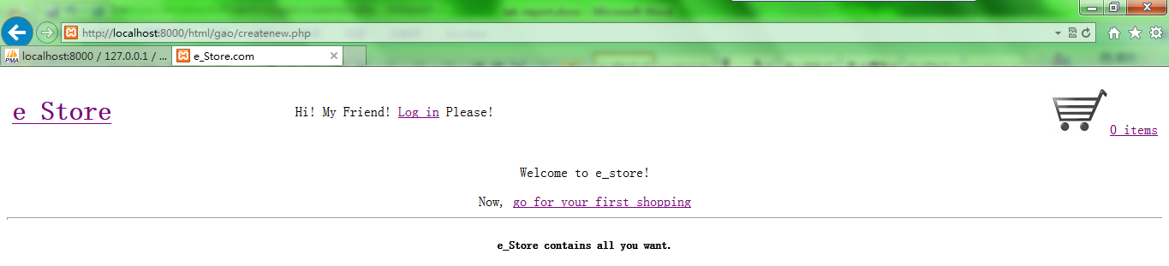

figure indicate user create successfully

Then it will lead customer to index.php again, but the page is a little different from the page when user not login.

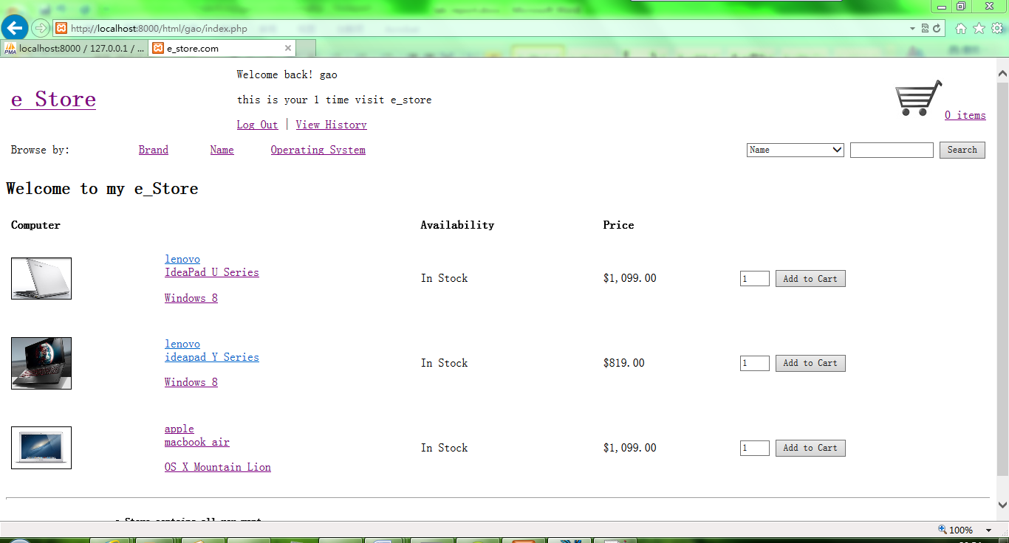

figure visit number showed in index.php after user login

In the middle of header, it displays the customer’s visit number. The number is stored in database and if customer log in, it will be read from database and then used to create cookie, usercounter. With this cookie, the page will display user’s visit number.

Each time user login, the counter will add one. If user link among pages and not logout or close browser, the counter will remain. To achieve the effect, I use the session ID to detect whether user reopen the browser, because if browser is reopened the session ID will change. Therefore, if the session ID in browser at present is different from the last session ID when load this page, which is saved in database, the counter will add one and then the counter and present session ID will be saved in database too. On the contrary, if ID is unchanged, counter will remain.

If the browser has cookie of username, the website will search the cookie and waive login step for customer. The page will directly display how many times user login. But the cookie will exist only one hour for website code.

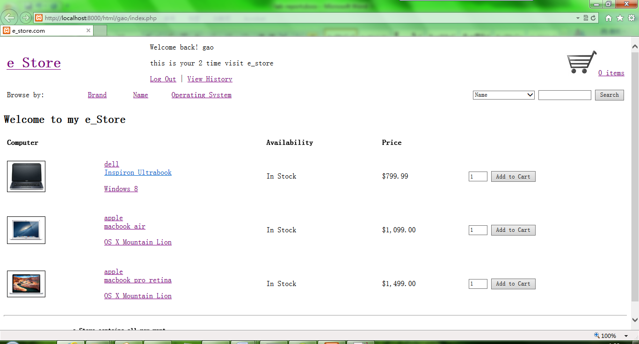

figure if browser save cookie for use, it display 2 time in header when user visit again

After customer login, he can begin pick up items. There are several ways to find his favorite computer. Firstly, some random items are displayed in index.php.

The item contains several important information, these are its brand, name and operating system. The number of item left in stock will indicate whether it available now. And its price will display of course.

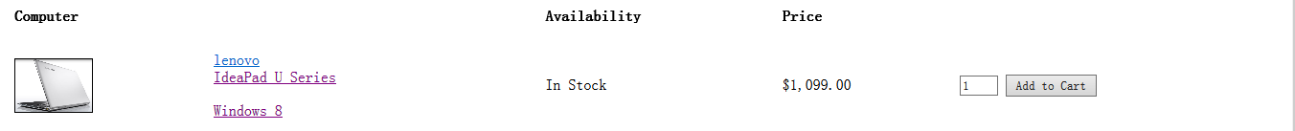

figure item information showed in page

Click picture of the item, it will turn to the item details page.

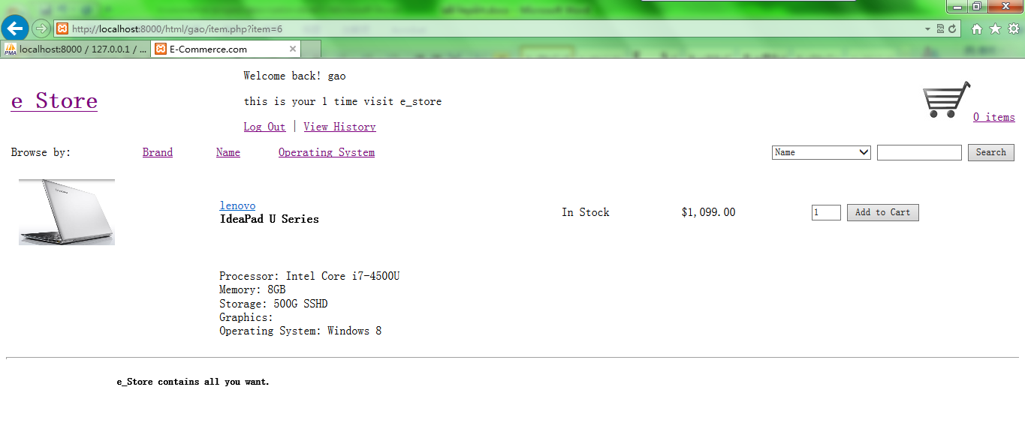

figure display item details

The second way to find favorite computer is to click hyperlink on the header. The brand link will display all the brands of computers stored in stock. Choose one brand and it will display all the computer of this brand. The operation is the same for browse by name and operating system.

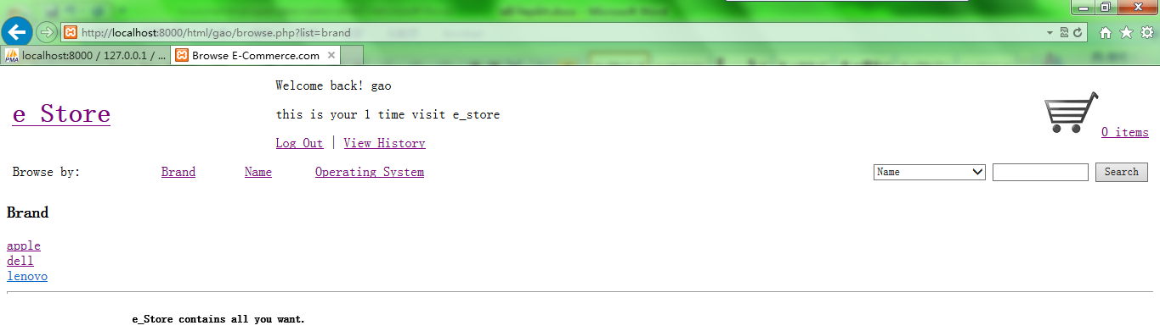

figure browse by brand

The third way to browse is use the search button on the right. Customer can search with key words. The figure shows the search result when search with “lion”. Of course, you can also click the hyperlink beside the items, for example apple or OS X Mountain Lion. It will show the result just like user search with these key words.

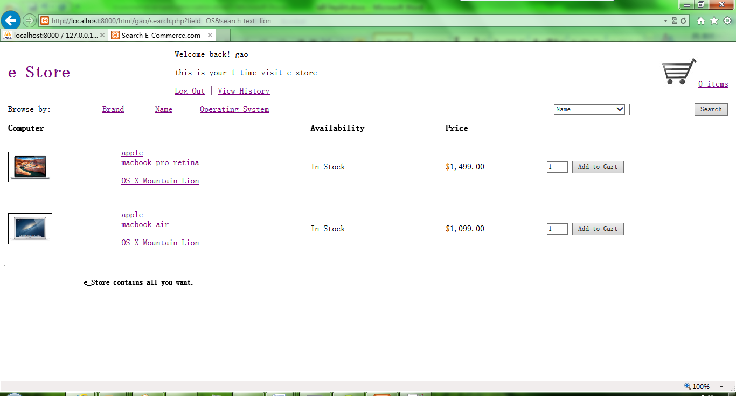

figure search result when search with "lion"

After select computers, we need to check these items in cart through click the hyperlink in the right of header. The cart contains all computer customer select in different pages. The website use session, cart, to transport variable between pages and show it in cart at last.

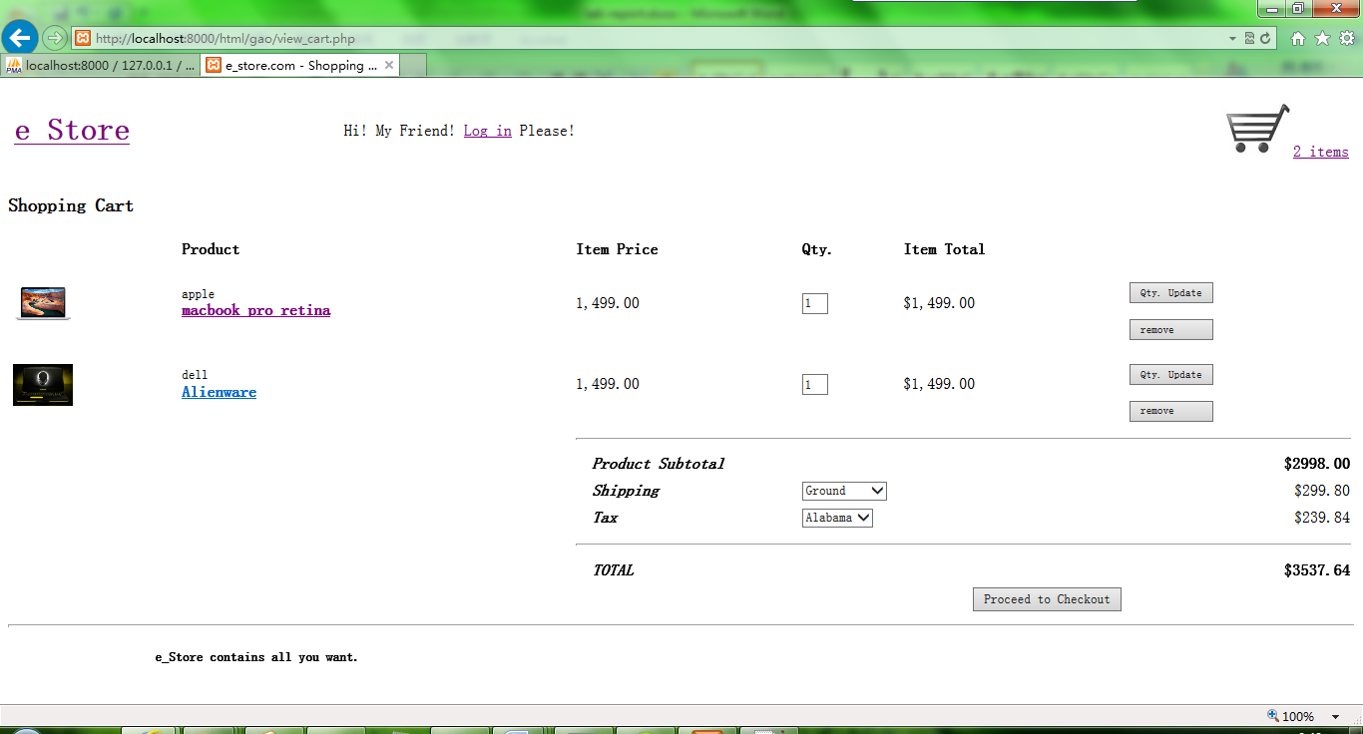

figure items in cart

I have changed the typeset to make it look nature. We can change quantity of computer or remove it. Click the button in the right and apply the change. There are three types of shipping available, that is ground, 2 days and overnight. Different type has different cost. The tax is distinct between in Alabama and out of state. Customer can choose it and it will cause different shipping address. If customer changed any options, the cost will be dynamically updated, without reloading the page. Click the “proceed to checkout” to continue the order.

In the checkout page, customer needs to fill in shipping address and credit card information. This information will be stored in database. The website will check available of the information user fill in. If there is any invalid information, it will prevent user to proceed.

There is a point need to be noticed that, the lastname in shipping address should be the same with the lastname customer used when login, because the lastname is used to place order and search in database. If user fills in other lastname, the outcome is that user cannot find his order in history.

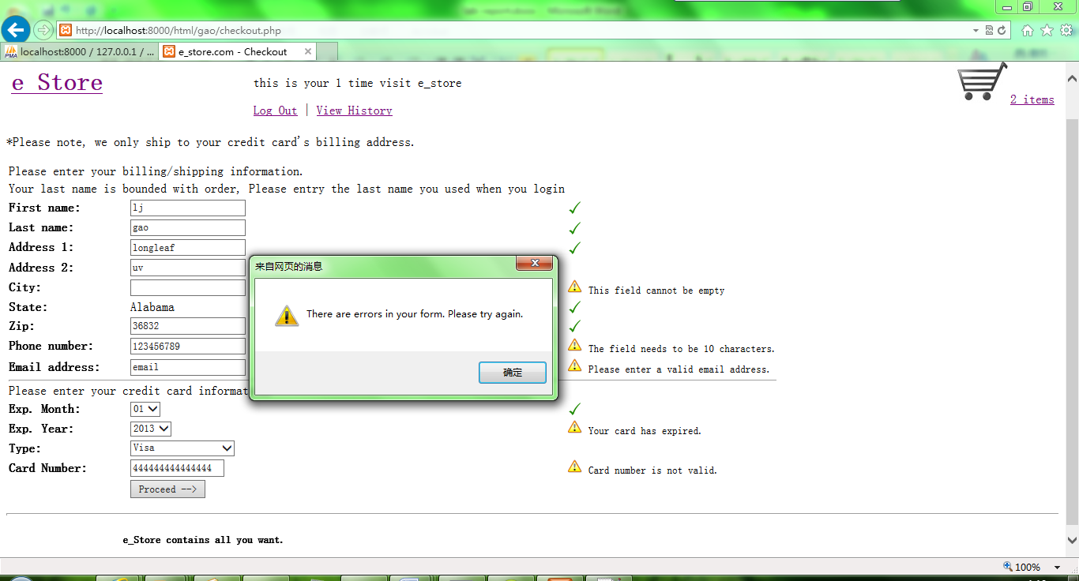

figure website check information availability

If customer fill in validate shipping and credit card information, then turn to the place order page. If the information is correct, then place order.

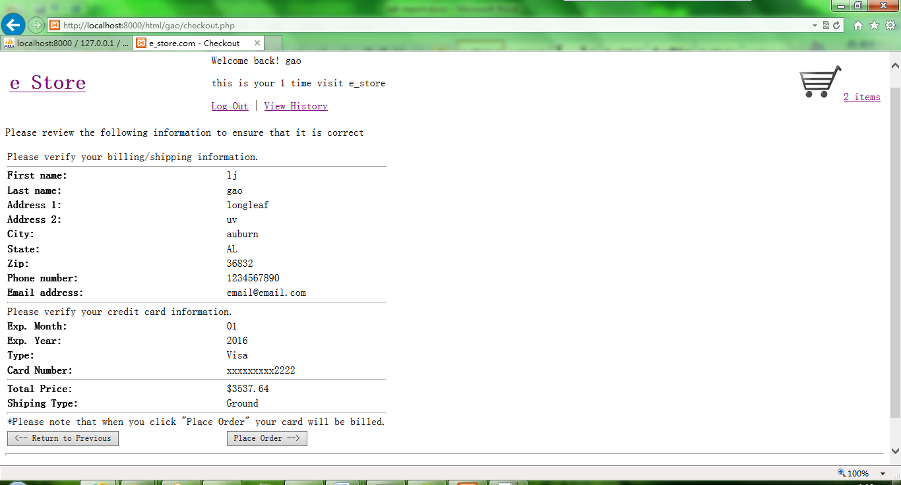

figure comfirm user's order

When the order is submitted successfully, order information will be stored in database at the same time. This information will be used in history, which will display all orders user buy.

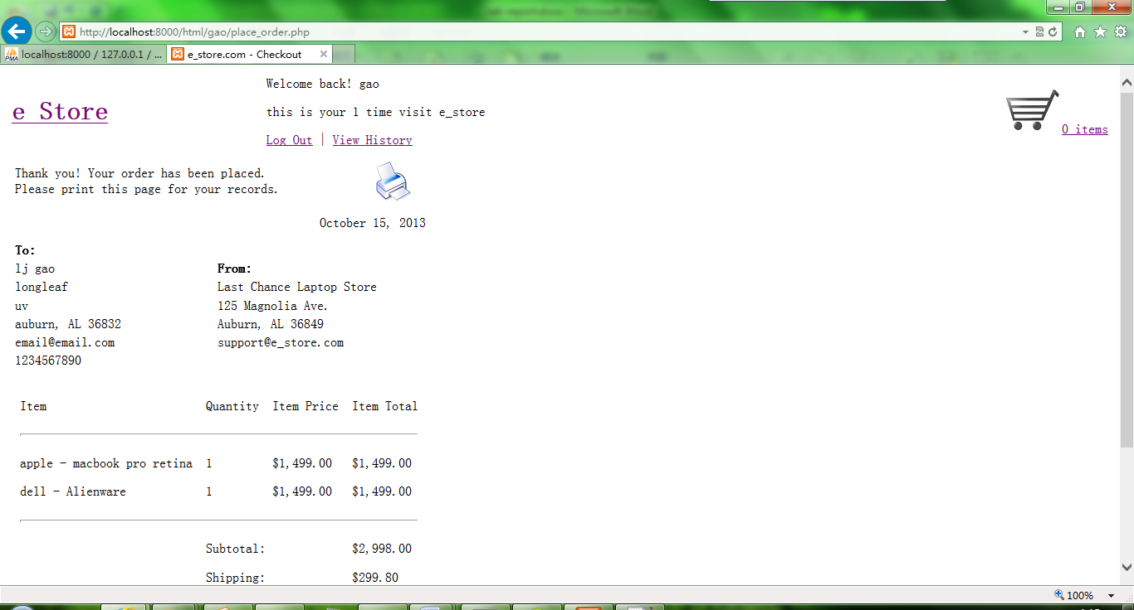

figure order submit successfully

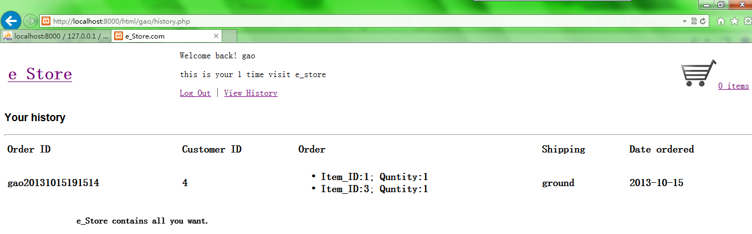

figure view the history of customer

When user finish his shopping, he can logout.

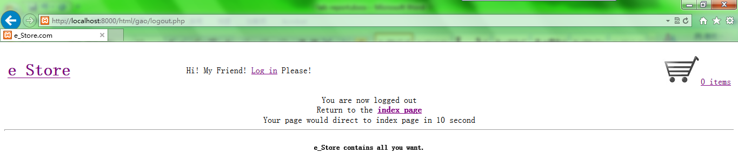

figure logout page

1. **ANDROID**

The website can also implement in android device. But the typeset of webpage may look different. I use android emulator on my PC to finish this project.

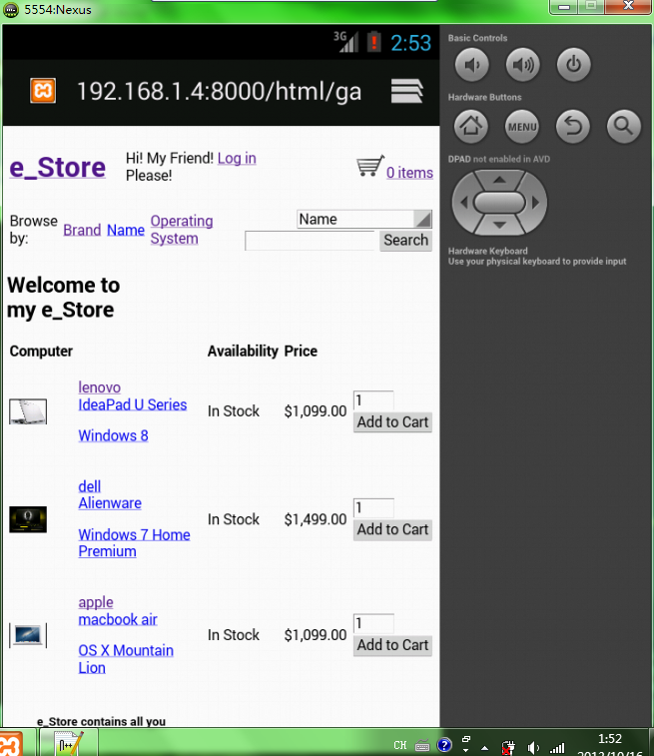

figure browse index.php in android emulator

User can login in android device and look how many times he had visit e_store. The step is the same as it is in PC browser.

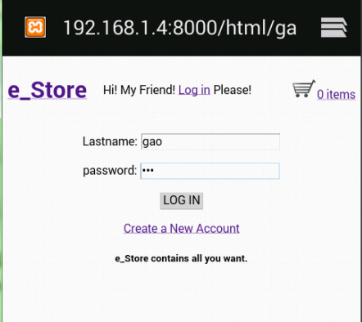 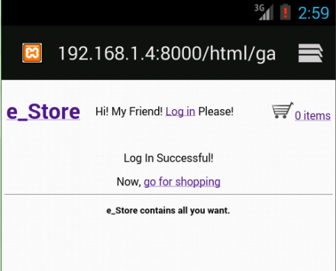

figure login page in android

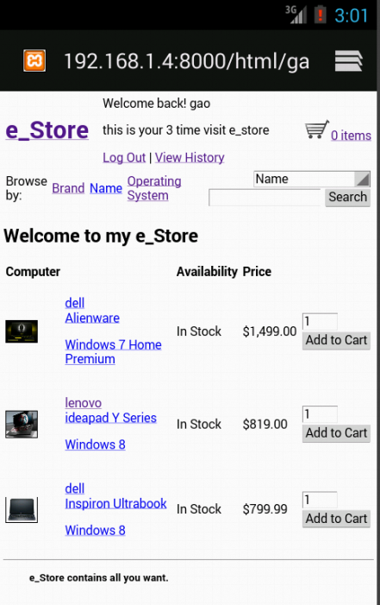 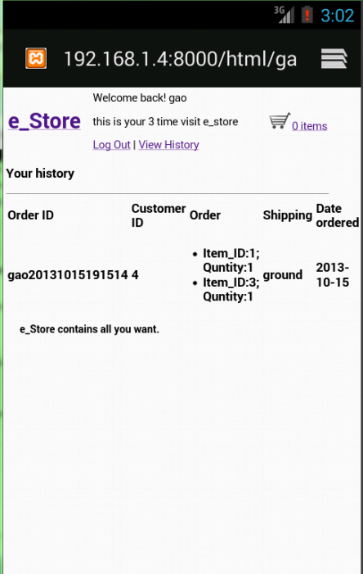

figure show visit times and history order after login

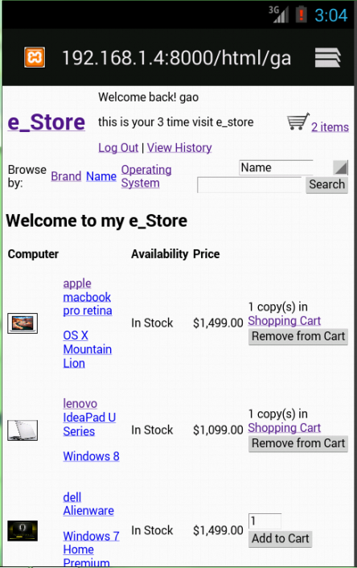 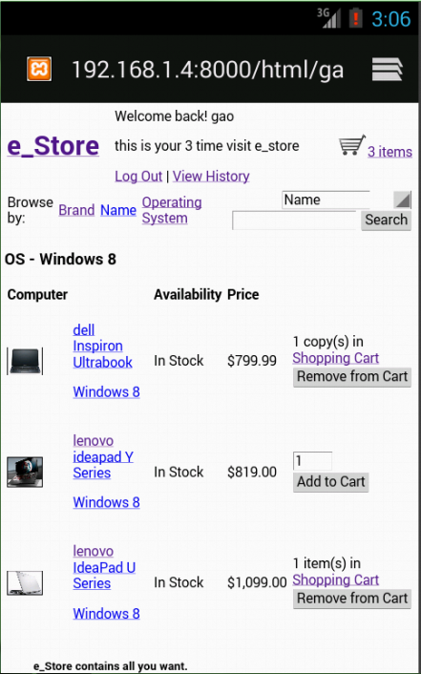

figure search items and add them to cart

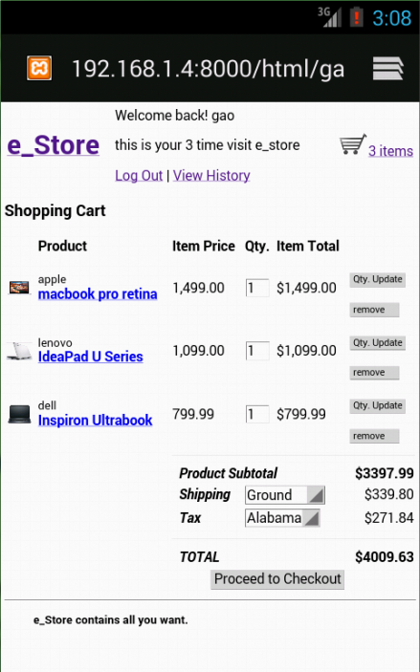 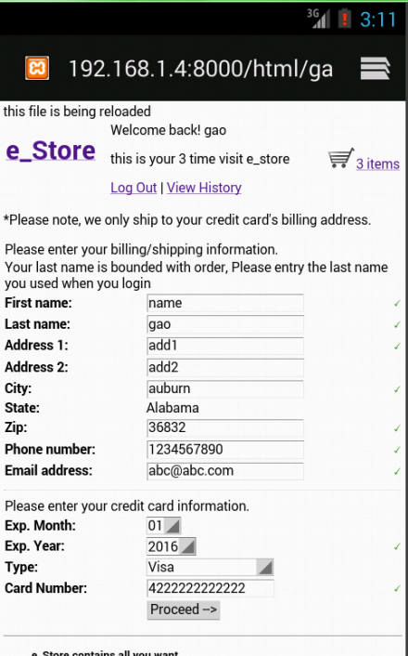

figure view items in cart and checkout

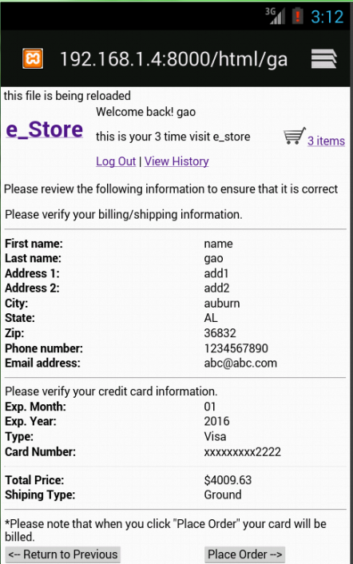 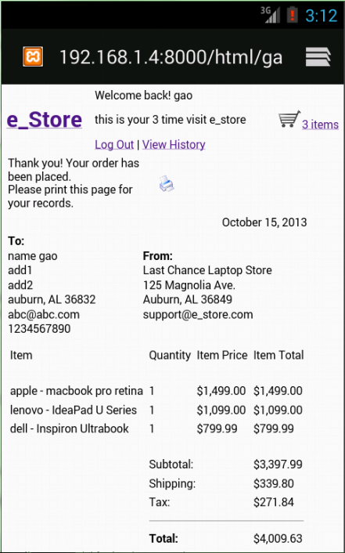

figure place the order and submit successfully

# Result

The project implements basic web store function. With several points I have modified from example, the website looks more like web store in reality. For example, customer needs to login at first. Items can be searched by multiply methods and added into cart. View the cart, checkout and fill in shipping address and credit card. Place order and review order history. Using session, items in different pages will converge into cart to checkout at last. Using cookie, website will check user and load user’s information, such as visit times.

# Conclusion

In this project, lots of knowledge in previous labs was used, such as HTML, PHP, SQL databases, and Ajax. These web script work together to make the e_store come true. Apart from practice the web script, I also learn how to combine many files together in an integrated structure. It may be the most difficult skills I have to learn in my later study.

# References

* sftp://scp.eng.auburn.edu /home/eewu/wuchwan/Teachings/5220-6220/Project
* <http://developer.android.com/sdk/installing/bundle.html>
* <http://www.w3school.com.cn/index.html>
* <http://www.gzsums.edu.cn/webclass/html/html_design.html>
* <http://www.cnblogs.com/yubinfeng/archive/2010/11/02/1867386.html>